Training Slides & Assessment Prep
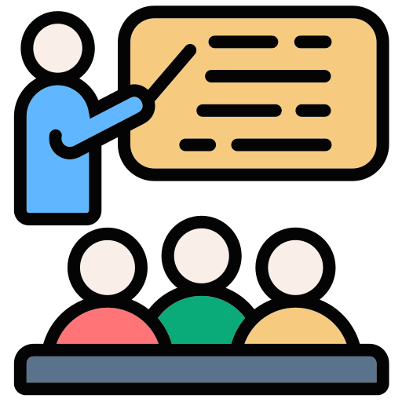

Training Deck Deep Dive & Assessments 🎓

For this task, you’ll spend 2 hours and 30 minutes immersing yourself in the training deck that you’ll soon use to guide your beloved merchants. This is your chance to channel your inner trainer and learn the ropes!

Step 1: Learn from the Masters 🏆

- Begin by watching video samples of your seniors in action.
- Observe how they ace merchant training—teaching merchants to navigate the system with ease and confidence.
- While you watch and read through the deck, take your own notes. Trust us, these notes will be your best friend later when you’re tested.

Video Samples:
Country | Deck |  | Video
MY | F&B | Retail | CN Version | EN Version
PH | Slide |  | PH Video

Pro Tip for Watching Videos 🎥💡

We know the videos might feel a bit lengthy, but don’t worry—you’ve got options!
- Speed things up: Play them at a higher speed to breeze through the content.
- Skip around: Jump to the sections you need to get the gist of the guide.

It’s all about making the most of your time while still getting the key takeaways. Happy watching! 🚀

Step 2: Put Your Knowledge to the Test 📝

Later in the day, you’ll be tested in a mock assessment with your coach. There will be 2 Training Assessments where you’ll showcase your training skills:
- Day 4 | 3:30 PM – 4:30 PM: F&B Training Assessment
- Day 4 | 5:00 PM – 6:00 PM: Retail Training Assessment

Here’s how the assessments will flow:
- First 30 minutes: You’ll conduct a mock training session using the checlist below.
- Next 30 minutes: Your coach will provide feedback on your performance.

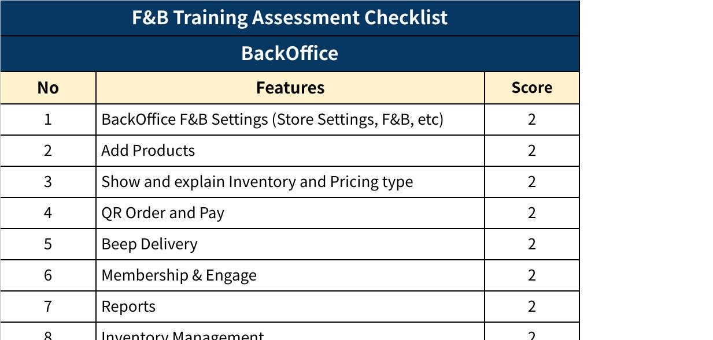
Click the image to view the sheet.
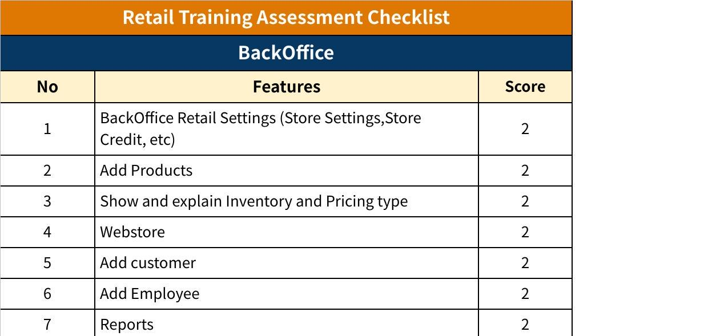
Click the image to view the sheet.

Important Tips for Success 🌟

- No Pressure: There won’t be a retake if you fail—but no worries, just have fun and stay natural.
- Be Engaging: Treat the session like it’s with real merchants. Smile, connect, and make it enjoyable.
- Be Prepared: Use the provided checklist to ensure you’ve covered all key points during your mock session.

All the best! Remember, this is your time to shine and prove you’ve got what it takes to rock the role. 🚀

